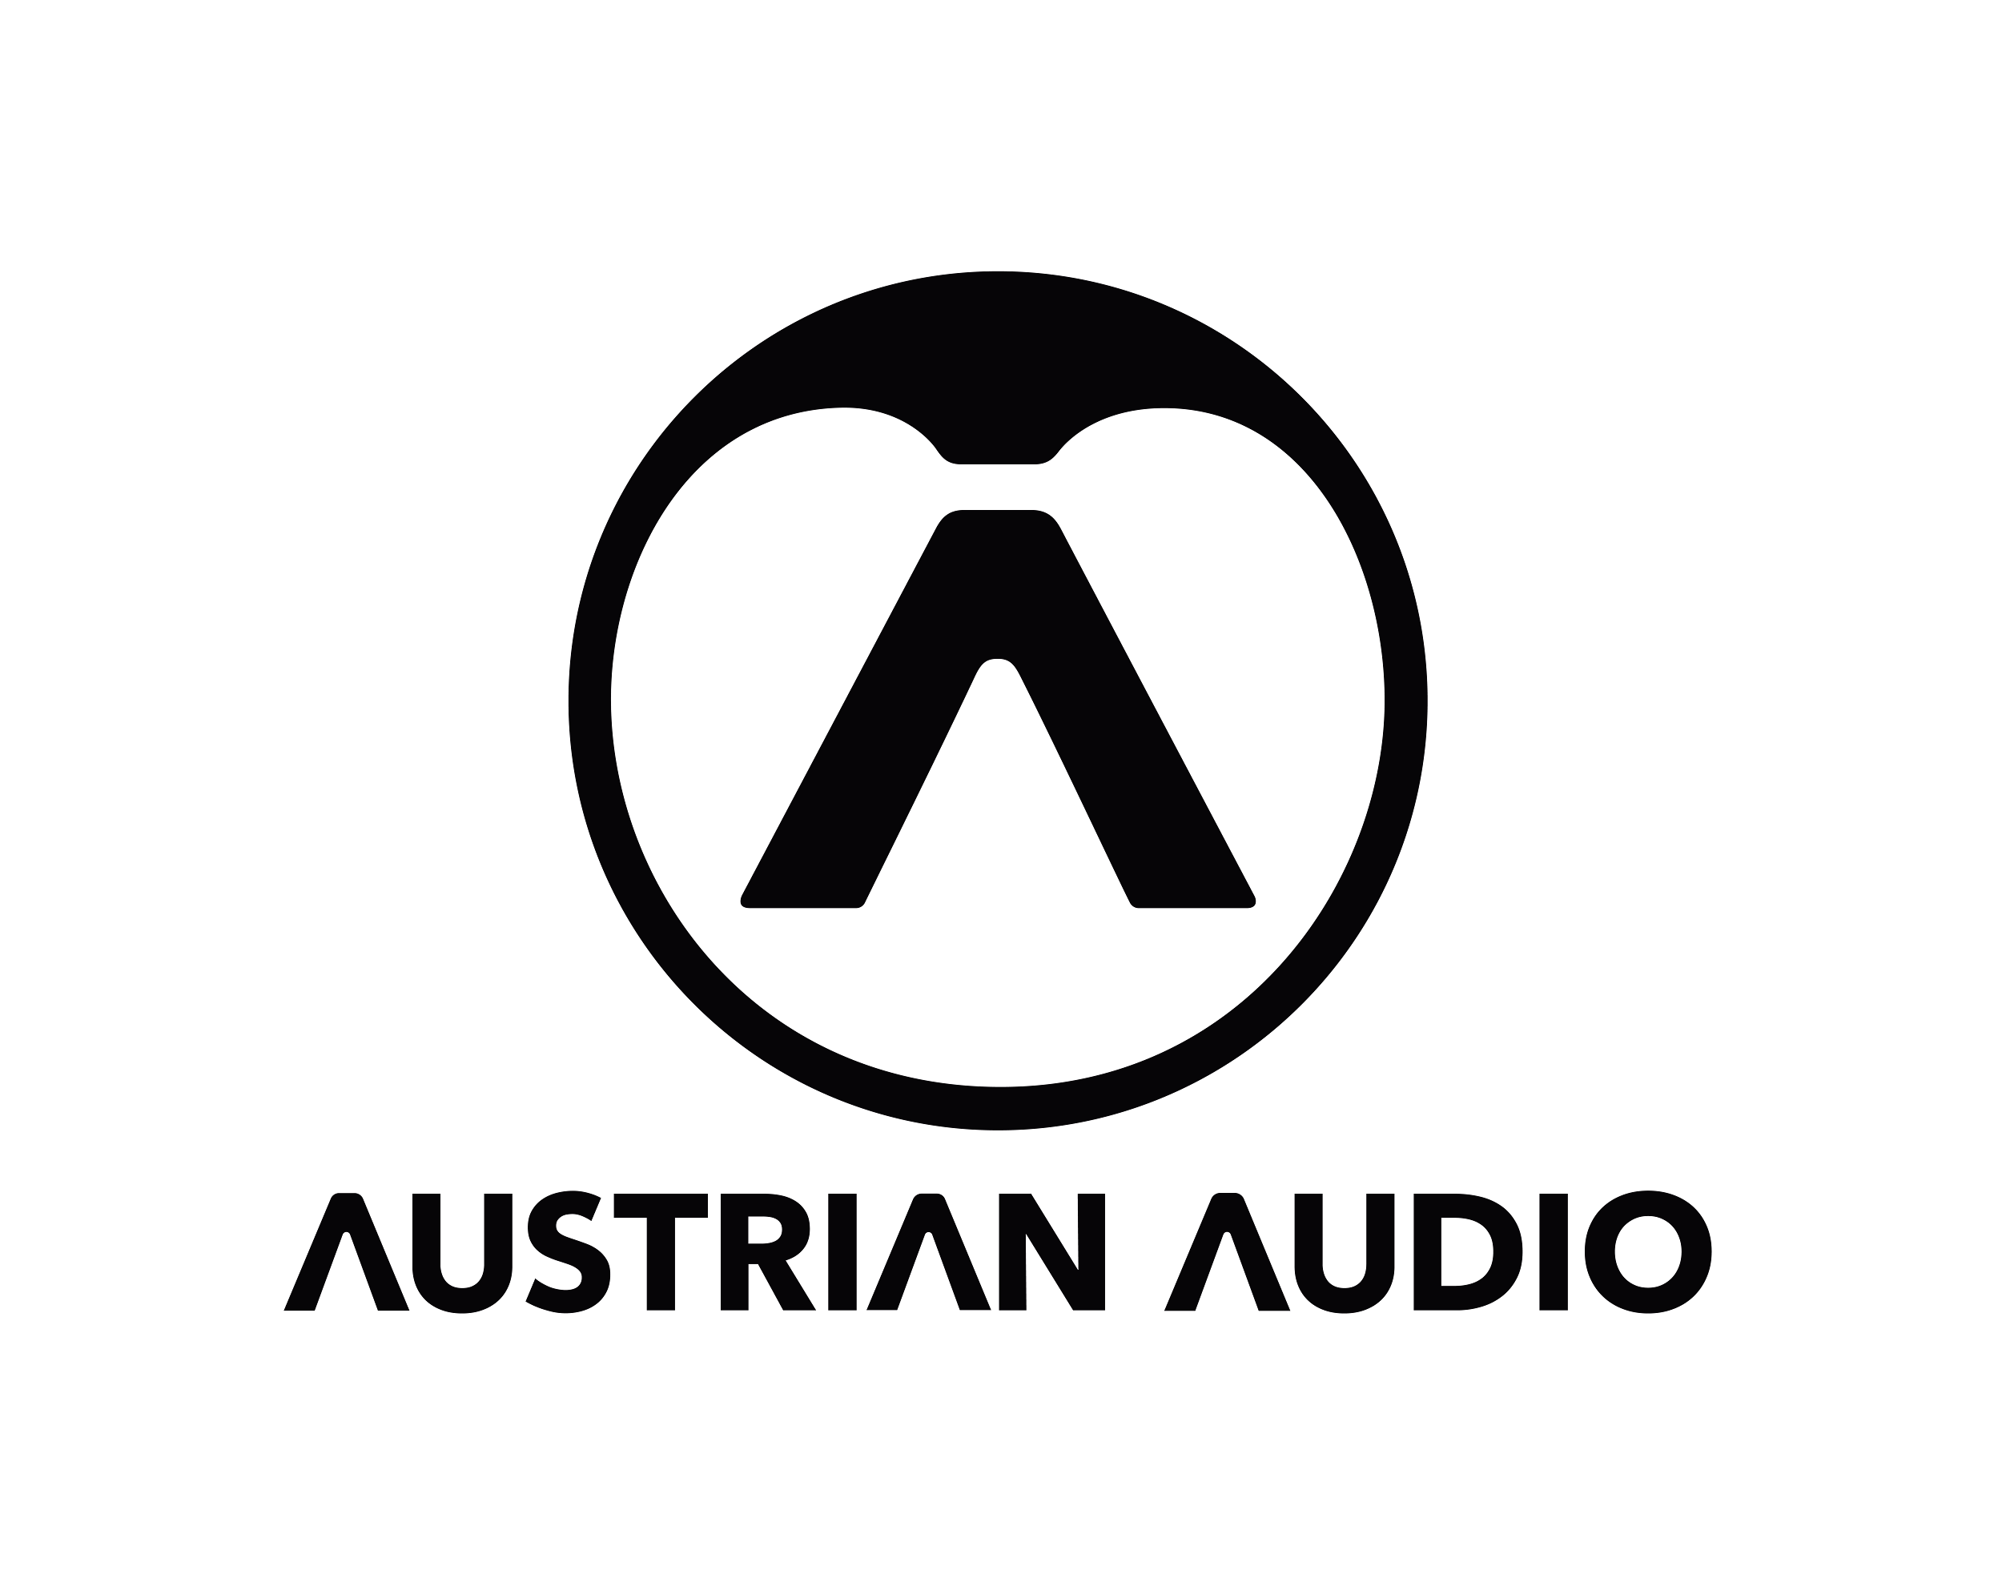

**Bob Strakele, FOH for Avenged Sevenfold and Slipknot, Takes Austrian Audio on Tour**

*Austrian Audio's line of dynamic and true-condenser microphones provides a consistent foundation for his drum mix.*

**Vienna, Austria, May 13, 2024 —** Bob Strakele leads a busy life, holding down the front-of-house mix position for both Avenged Sevenfold, who recently completed the third leg of an ongoing tour, and Slipknot, who debuted a new drummer in late April at the band’s first shows since October 2023. Strakele likes to keep things consistent regardless of which band he’s working with, typically using the same mixing console and P.A., and deploying Austrian Audio microphones — including OC818 large condenser, CC8 cardioid small diaphragm condenser and OC7 condenser instrument models — on the drums.

Strakele’s resume is diverse and includes tours with War on Drugs, Greta van Fleet, AWOLNATION and Erasure. But since signing up with Avenged Sevenfold in 2018, taking over from the late Dave “Shirt” Nicholls, he says, “I've been pretty much in the metal scene.” About a year after hooking up with Avenged Sevenfold, Slipknot — who Nicholls also mixed, for almost 15 years — were ready to get back on the road and tapped Strakele for the FOH job. He’s been deeply involved ever since, jumping between the two bands as they each tour the world.

**Anchoring the drums with Austrian Audio**  
Whichever band he’s working with, he says, “I try to develop a relationship where they understand that on the first leg of the tour we're going to go through a lot of microphones, just to see what works the best. Thankfully, they trust me to do my thing.” Over the past year, to help maintain a consistent drum mix, Strakele adopted several models of microphones from Austrian Audio and currently uses them with both bands. “I'm using two Austrian OC818s on overheads, OC8s for my ride cymbals and I'm using the OC7s on the floor toms,” he reports.

“The OC818s are what I've been using with Avenged,” he continues. “I put them in cardioid to get the rejection off the back side.” He also has a pair of OC18s, he says, which has a fixed cardioid pattern in contrast to the three switchable patterns of the OC818.

**Capturing the big picture with Austrian**  
The OC818 pair provides the foundation of his drum mix, Strakele elaborates. “For me, it's not a cymbal mic. I am basically catching the big picture, with the mics boomed in from behind, equidistant from the snare. I'm a big fan of building my whole drum sound around the overheads. Everything sounds better to me when I moderately high pass filter them, maybe at 80 Hz or 100 Hz, just to get rid of any rumble if there are subs on stage. But I like to hear that woody snare sound, so I don't tend to high pass them too hard. And if you add EQ, then you're taking away from the snare sound.”

When first trying the OC7 mics on the floor toms, he says, “We set up two sets of mics and slowly introduced them once I knew that it was what I wanted. They have a tremendous low end and an immediacy; they're fast.” He adds, “The OD5 [active dynamic] and OC7 surprisingly sound identical to each other where normally a dynamic would sound a little bit boxy or not hyped on the top end. I could use them interchangeably.”

The OC7s are mounted on LP brand claws attached to the legs of the floor tom. “They're not pointed directly at the center of the drum, but they’re not straight down either. They’re pointing maybe three or four inches in from the rim.” The OC7s and the OD5s have an ingenious swivel-mounted head design, he also notes, that adds flexibility to positioning options when miking a drum kit and space is limited.

Strakele first heard about Austrian Audio microphones from a good friend, producer and engineer Joe Barresi, who produced the latest albums by both Slipknot and Avenged Sevenfold and has also recorded Tool, Chevelle, Bad Religion and a host of other bands. “We were on the phone one day and he said, ‘I got these Austrian Audio mics; you need to try them on drums. I set up a floor tom in the middle of my studio, surrounded it with cymbals and had my assistant just pound it. It sounded great and we got good rejection.’

"Since then, I've been in touch with Bernd [Gossi, Artist Relations] from Austrian and he's been providing me with great support - both on the tour and off."

**Working with three drummers on Slipknot**  
His two principal artists are very different when it comes to the live mix. “It took me a long time to learn how to mix Slipknot, just because it’s so chaotic. There are nine guys on stage and at certain times there are three drummers playing — and sometimes they're hitting kegs with flaming baseball bats! I don't want to say Avenged Sevenfold are easier to mix, but there's a lot more space.”

The music balance is very different, he continues. “With Slipknot, it's like the guitar and bass relationship is almost backwards. Normally, the bass is the foundation, and the guitars are the mid-range hump. With them, it's a kind of a scooped sound and the bass is played through guitar amps, so that's your mid-range punch. And that's the part that you're trying to get to lock with the kick drum. The normal drum kit is so low-end and high-end heavy that when you have three drummers, you can't just put them all in the same frequency range or else it sounds like you're throwing a bunch of rocks down a set of stairs!”

**Austrian Audio: what's best for the show**  
This will be another busy year for Strakele. Slipknot, who last played nearly six months ago, are back on the road with a new drummer and a string of U.S. festival dates, including Sick New World, Welcome to Rockville, Sonic Temple, Louder Than Life and Aftershock. Then, Avenged Sevenfold head to Asia and Europe for a series of summer festivals. In November, Slipknot return to the road for shows in Mexico followed by a month in Europe and the U.K.

Ultimately, on working with Austrian Audio, he says, “I just want what's best for the show, so let's just get what sounds the best. If you don't have a good drum sound, the whole mix falls apart. A good snare and a good player are the first part of the equation; I'm just putting the sprinkles on top.”

To keep up with Austrian Audio’s latest news, sign up for the Austrian Audio newsletter [here](https://austrian.audio/newsletter/).

**About Austrian Audio**

Austrian Audio opened its doors in 2017 following the closure of the AKG offices in Vienna and set out to create something new, challenging, and respectful to its heritage. The new company started with a core team of previous AKG personnel from management, acoustics, electronics, test and measurement, mechanical design, RF/wireless, and software/firmware, bringing 350 years of cumulative engineering experience to the new company.

For more information, visit [austrian.audio](https://austrian.audio/).